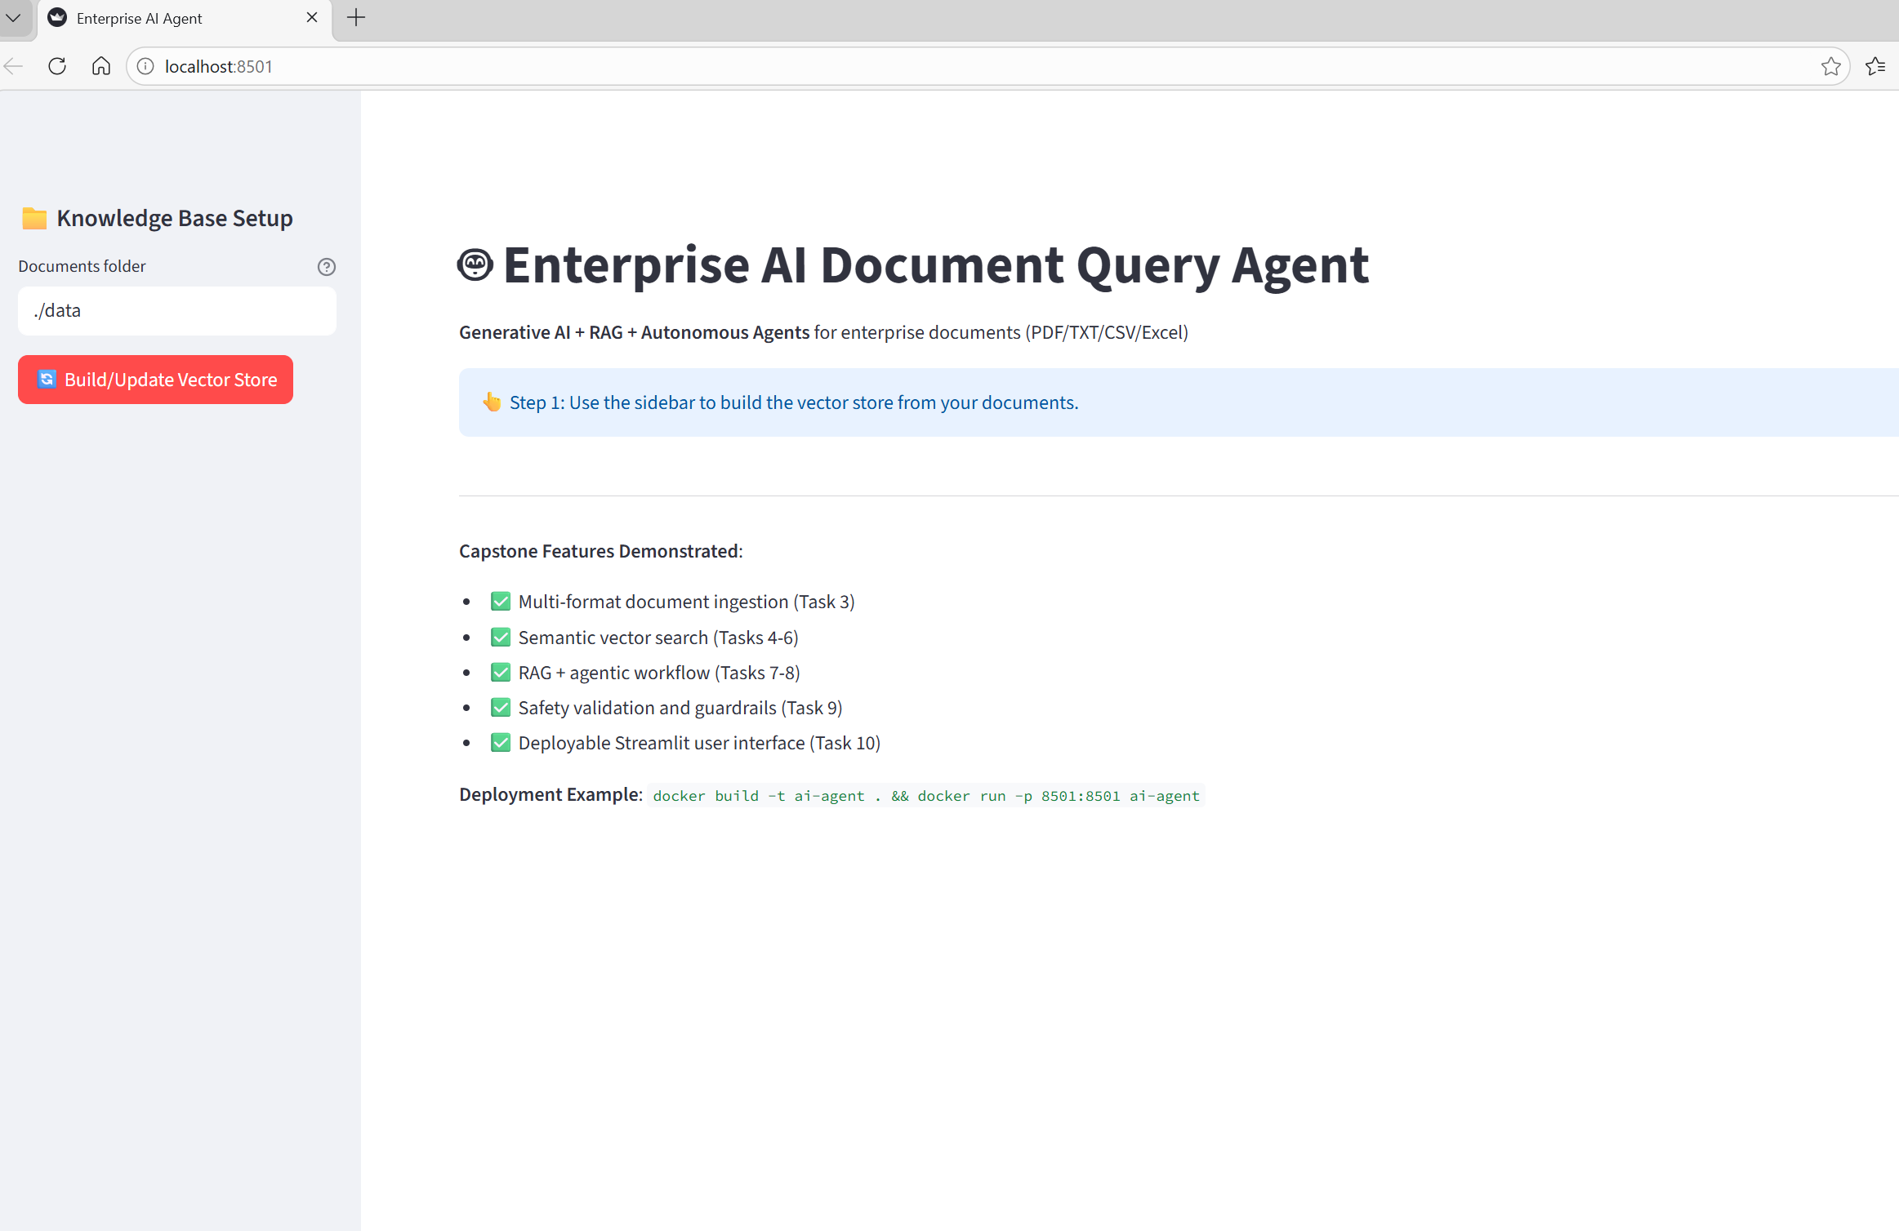
This screenshot shows the initial landing state of the application, where the user is instructed to build the vector store from the uploaded documents before starting queries. It demonstrates the guided setup flow and improves usability for first-time users of the system.

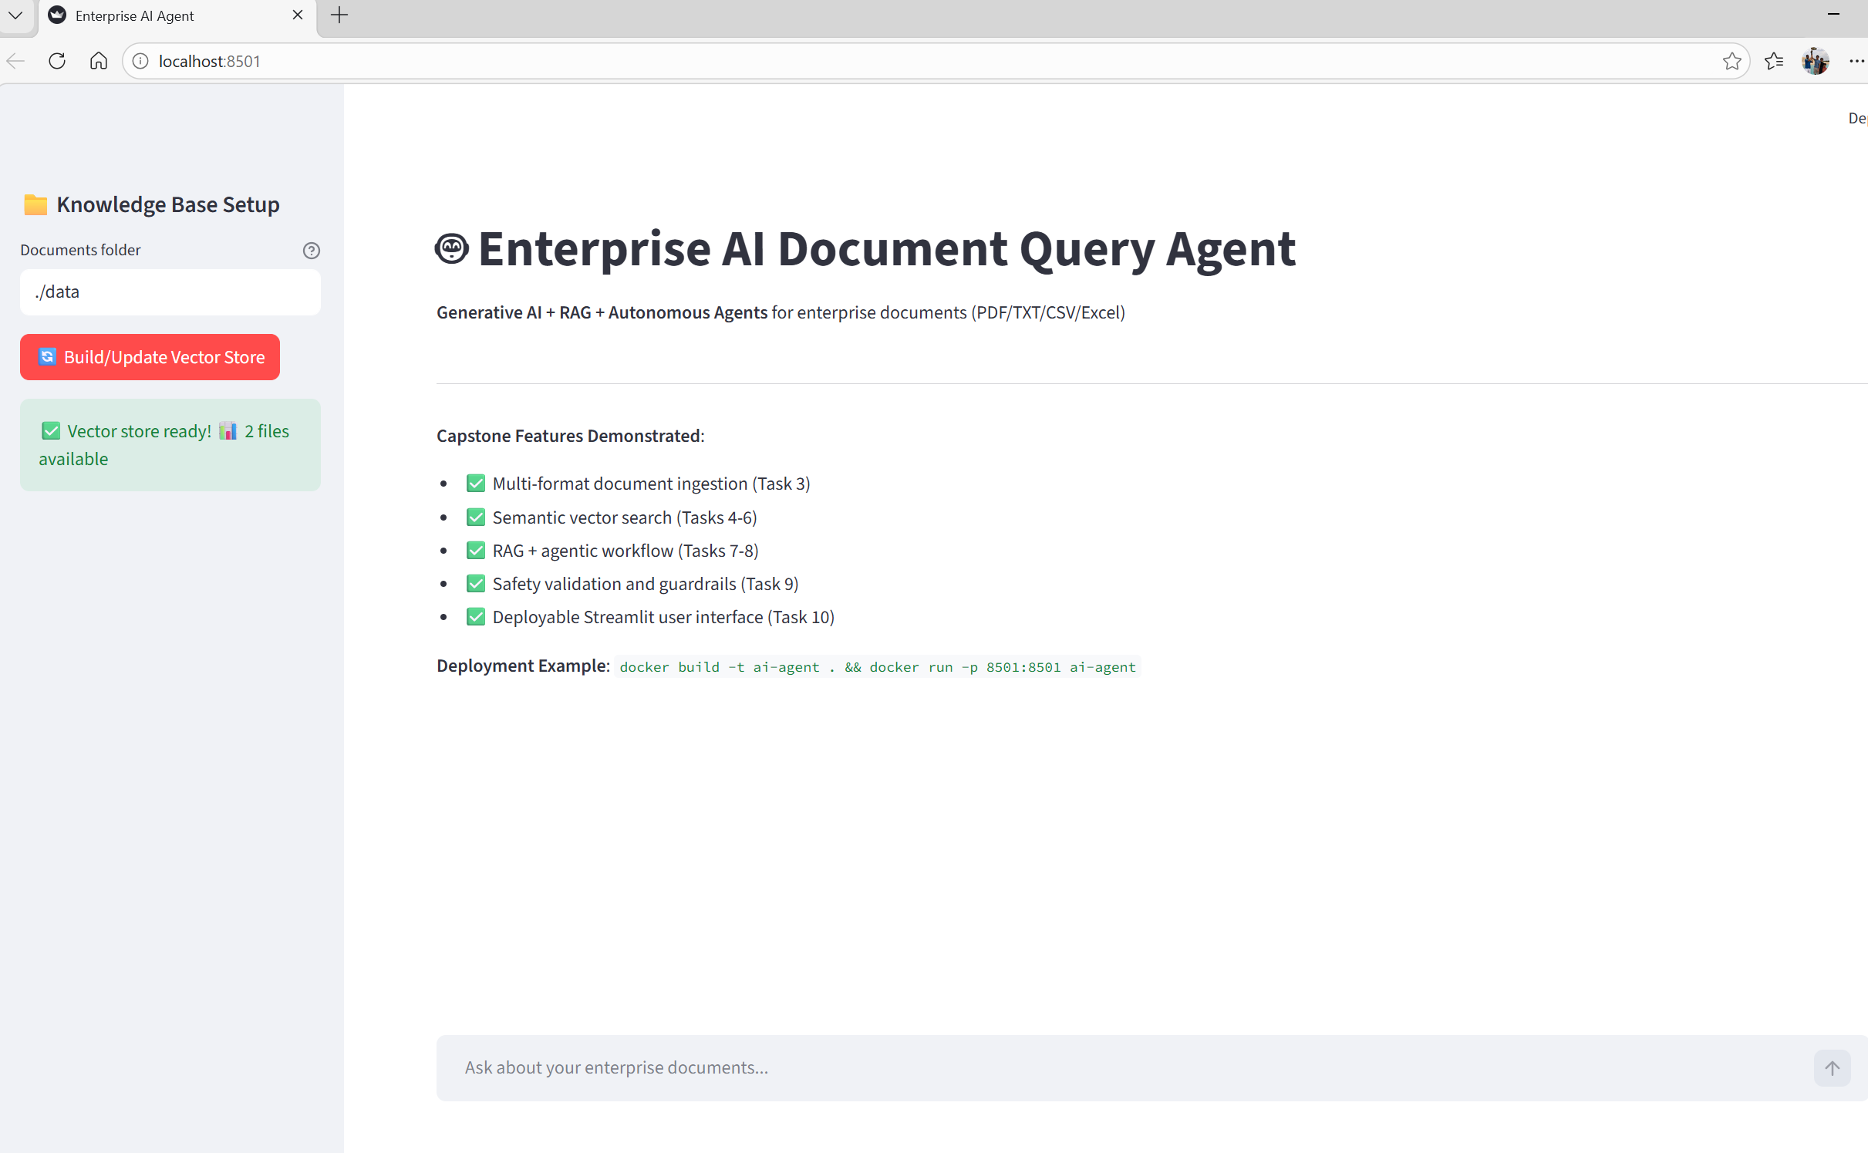
This screenshot presents the main user interface in a ready state after the knowledge base setup is complete. It confirms that the deployed Streamlit application is prepared to accept natural language questions over the indexed enterprise documents.

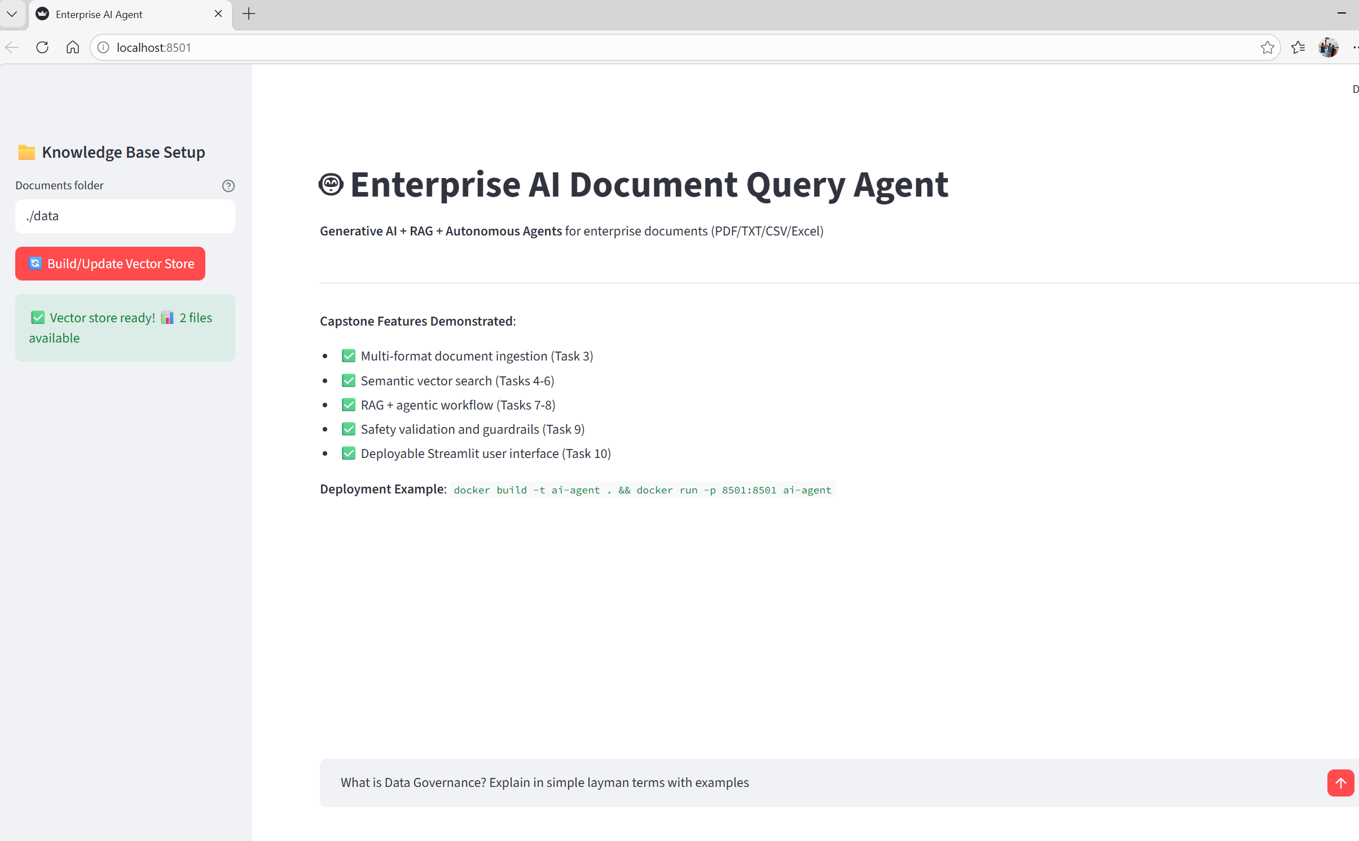
This screenshot shows the application after the vector store has been built successfully, with the sidebar confirming that files are available for querying. It demonstrates that the ingestion, chunking, embedding, and vector database setup phases have completed successfully.

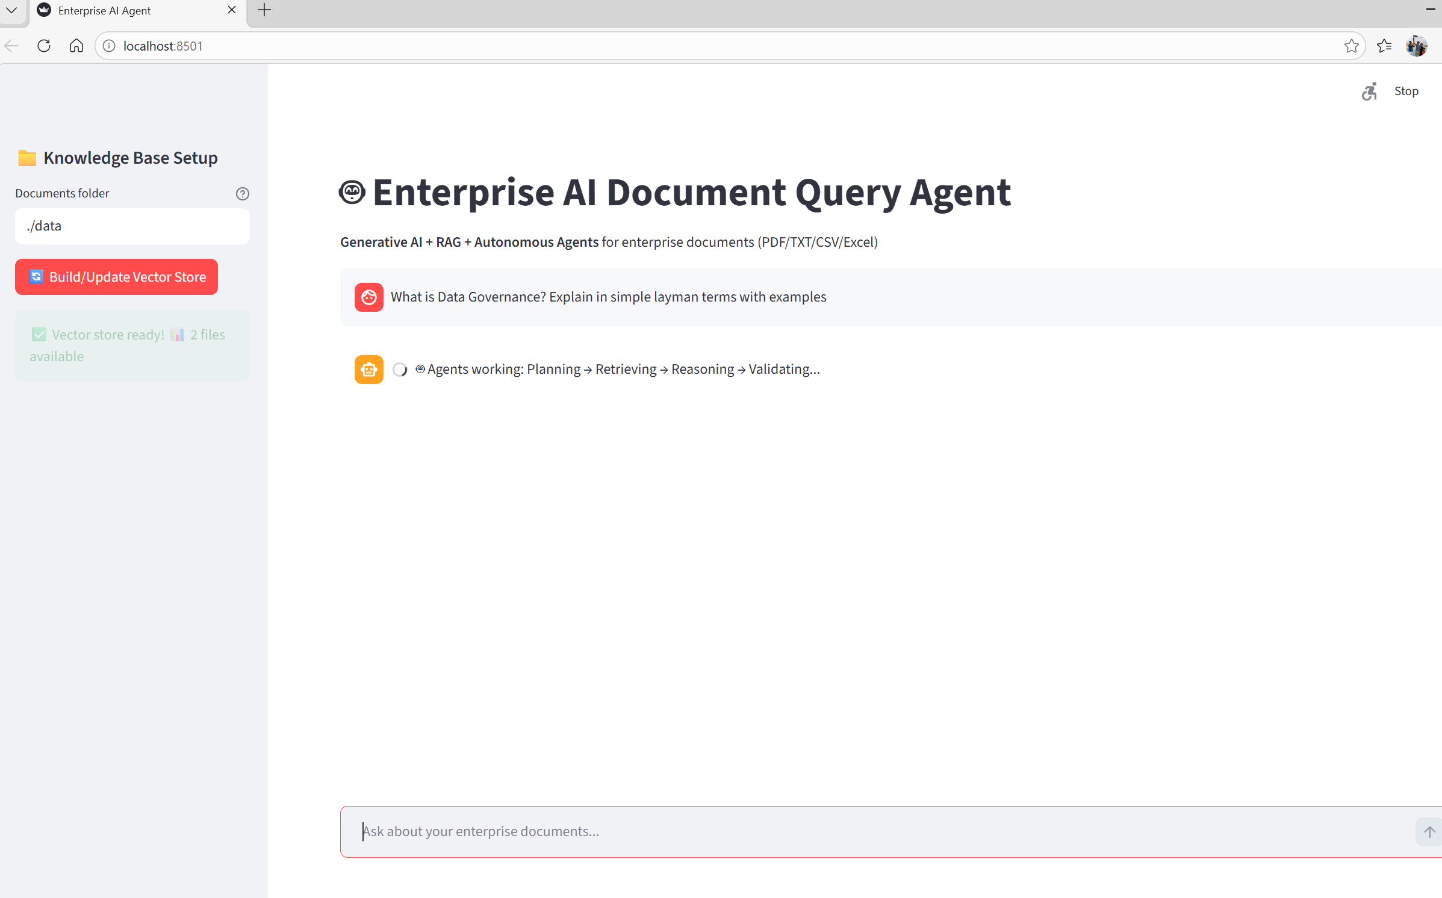
This screenshot shows the application while the agents are actively processing the user query through planning, retrieval, reasoning, and validation steps. It illustrates the live execution of the multi-step agentic workflow required by the capstone.

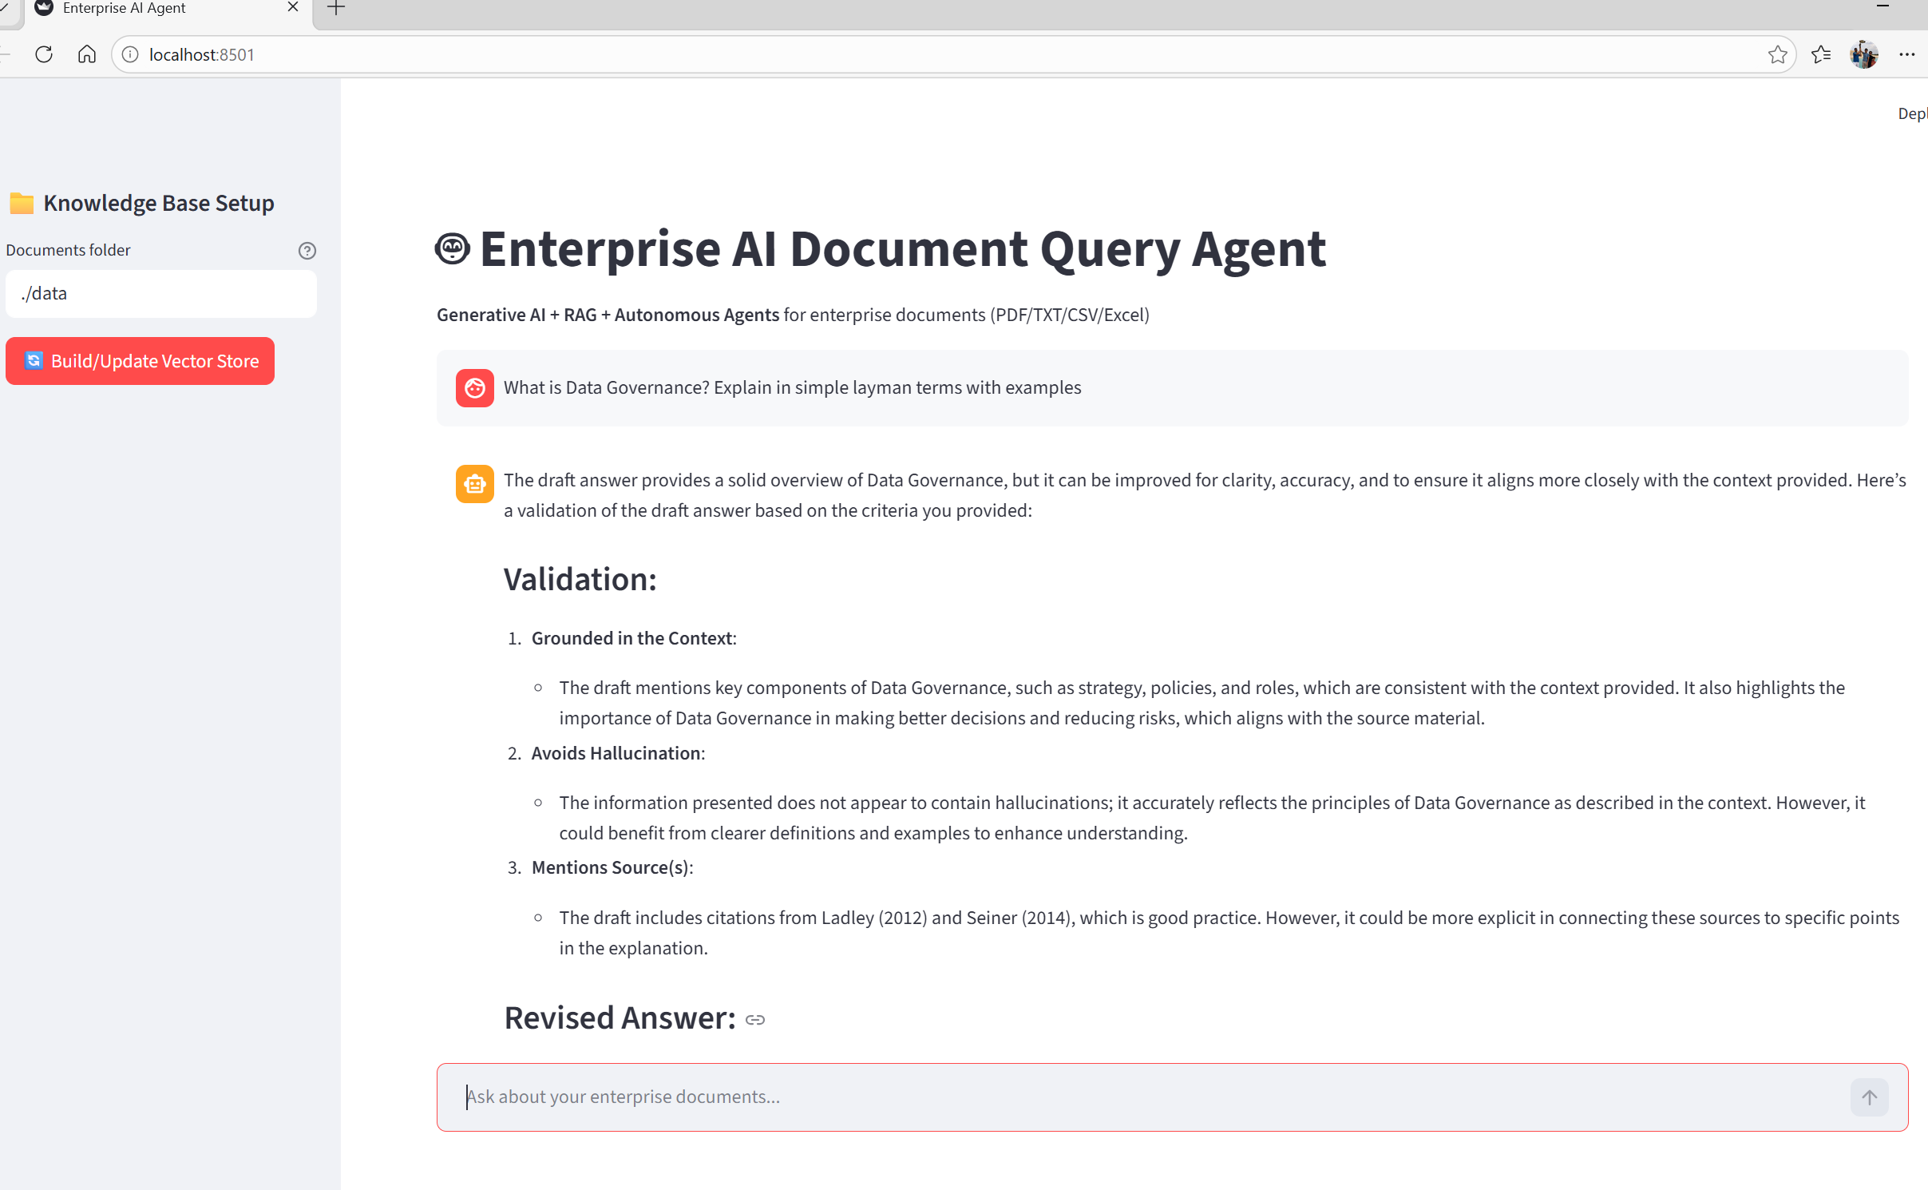
This screenshot highlights the validation stage, where the system evaluates whether the generated answer is grounded in context, avoids hallucinations, and mentions sources. It demonstrates the agent-based reasoning and reliability control features built into the solution.

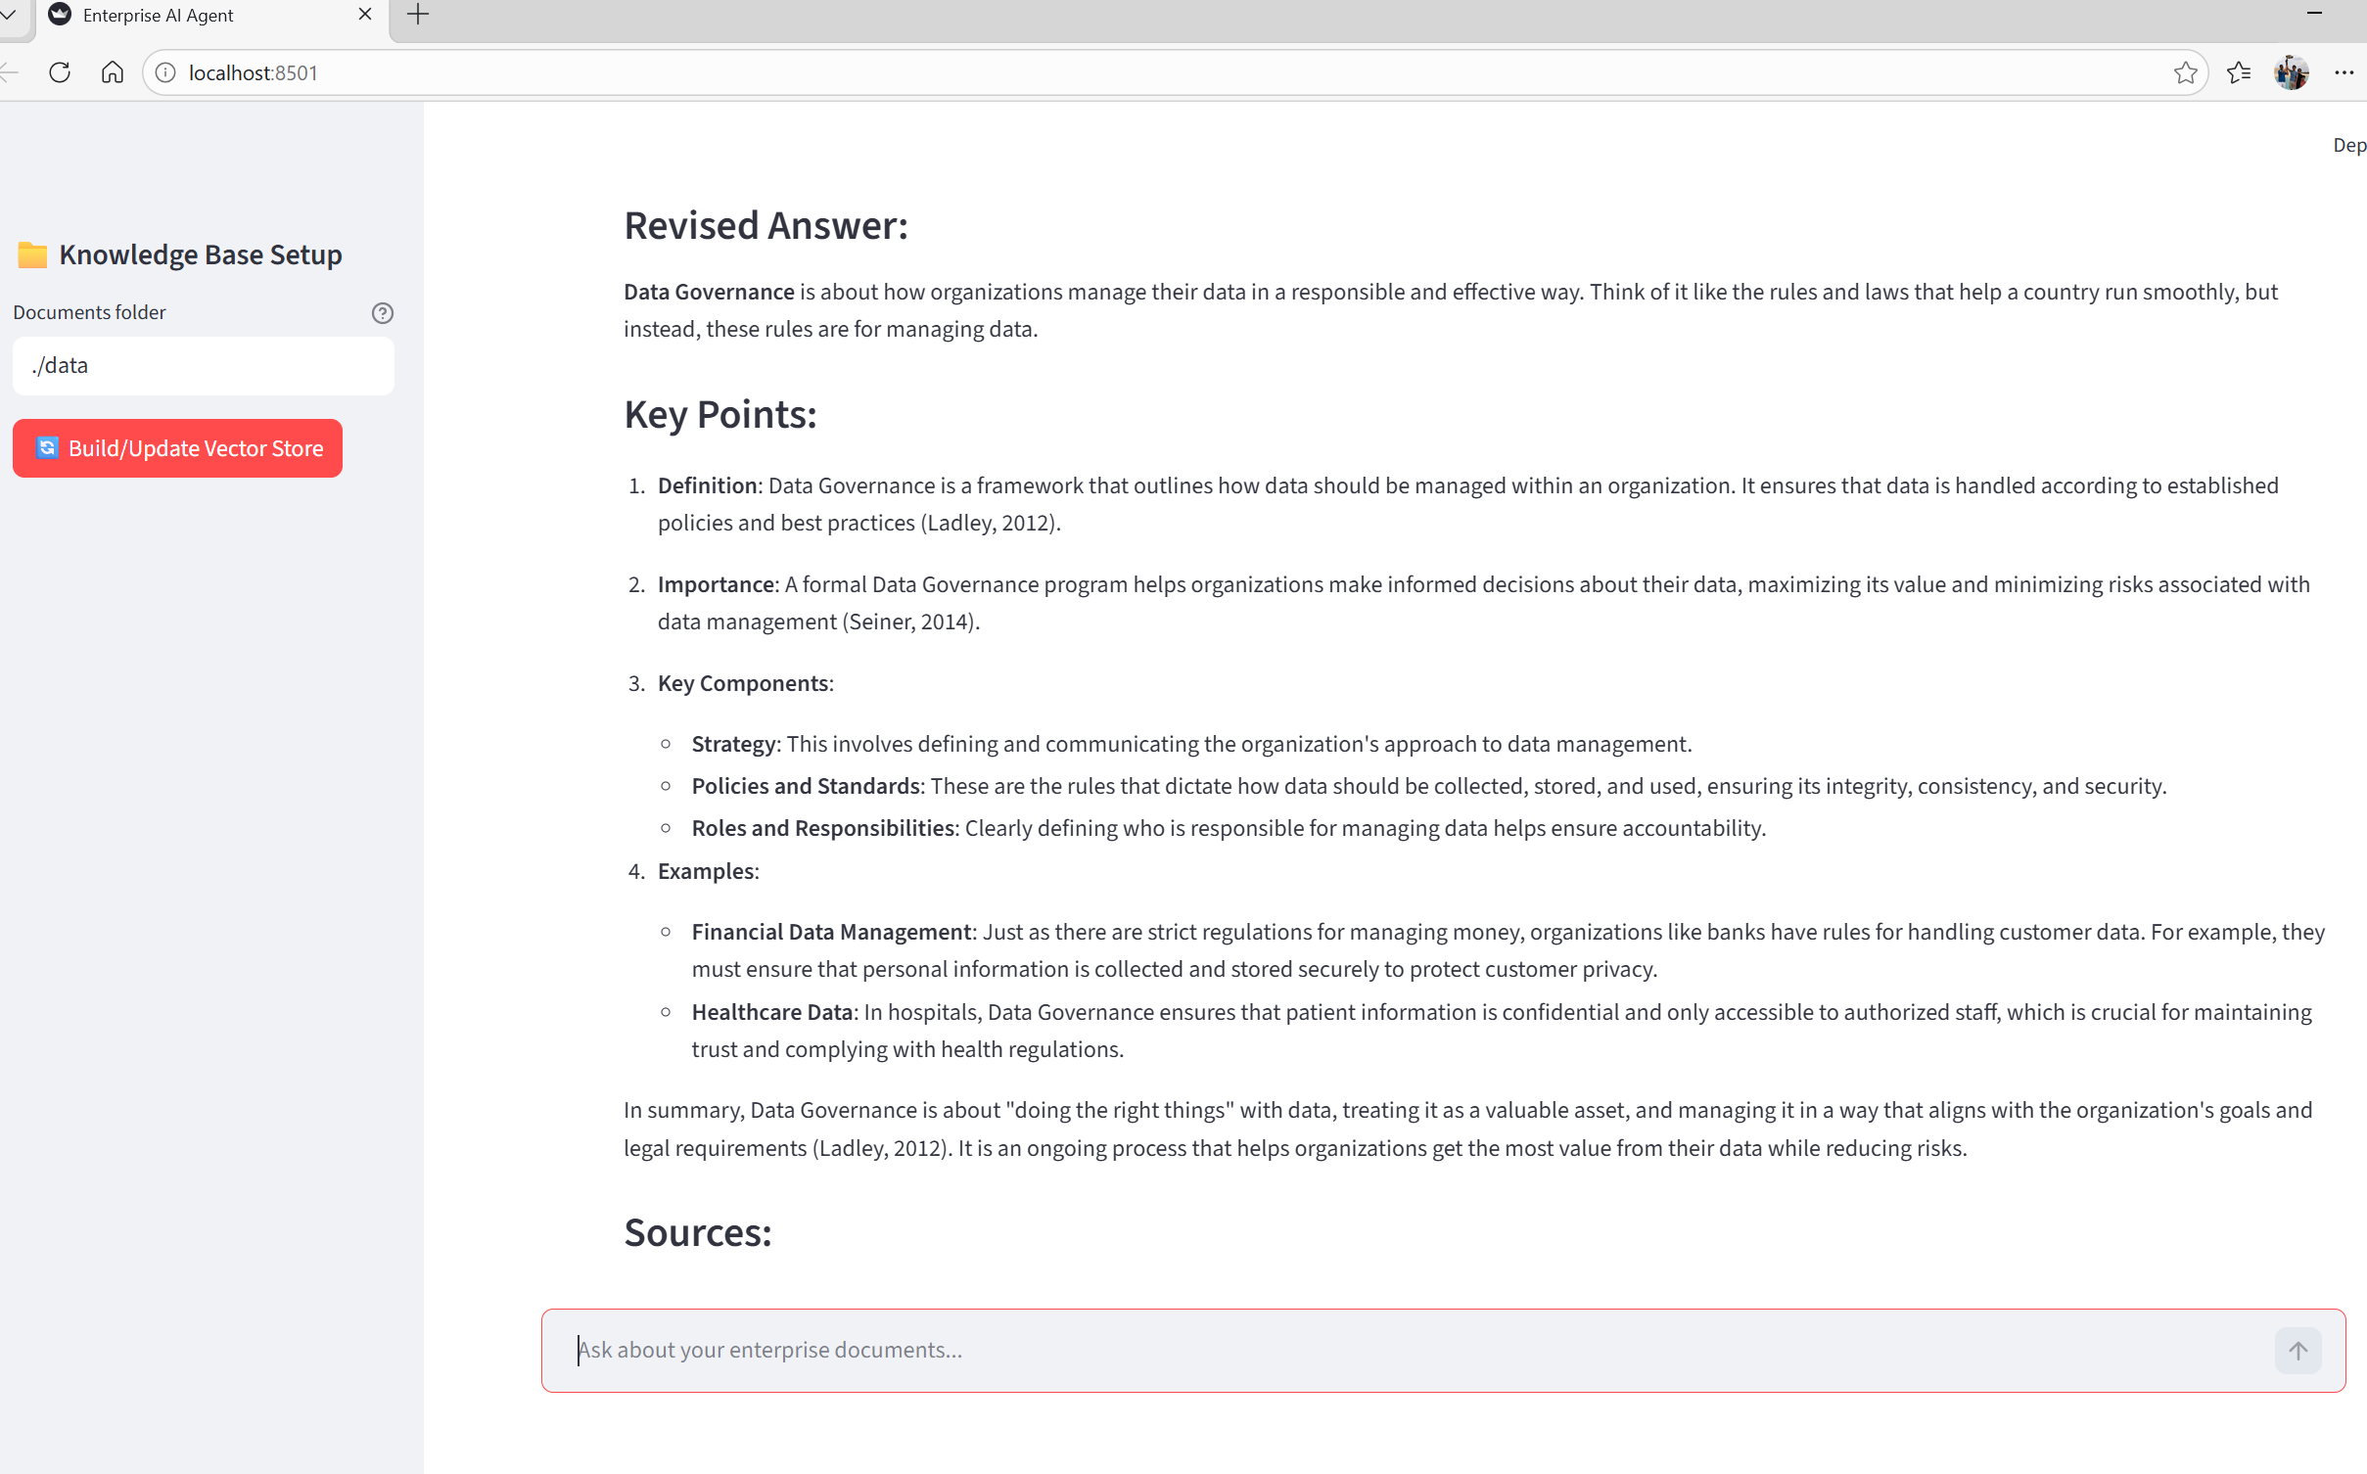
This screenshot presents the revised answer in a structured format with key points and source references. It shows that the application can return user-friendly, summarized responses while maintaining traceability to the retrieved document context.

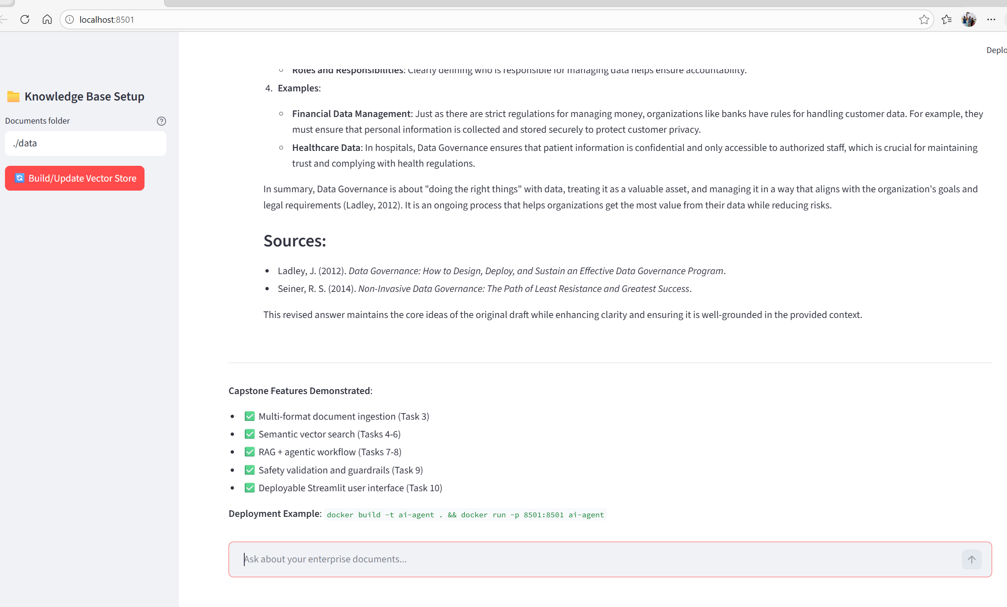
This screenshot shows the final response section of the application, where the system displays a grounded explanation of data governance along with cited sources. It demonstrates that the RAG pipeline successfully generated a context-aware answer from the uploaded enterprise documents.

